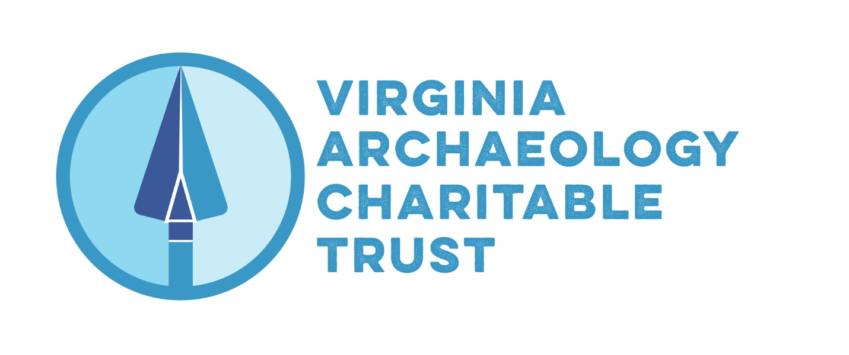
Board Meeting November 11, 2021: 9AM via Zoom
Agenda:
- Review organization of BOD – expiration of terms, reappointment

Randy Lichtenberger (COVA) – President -
Dave Brown (COVA) – Vice President
Crystal O’Connor (COVA) – Secretary
Karen McIlvoy (At-large) – Treasurer
Tom Cuthbertson (At-large) – Media Coordinator
Carole Nash (ASV)
Mike Barber (ASV)
Hannah Burns (ASV)
Chris McDaid (ASV)
Jack Gary (COVA)
Eleanor Breen (At-large)
VACT Board Members and Terms as of June 2021
Name | Organization | Title | Current Term begin and end | Which term in office is this? | How many possible 2-years terms left?
Randy Lichtenberger | COVA | President | August 2020 to August 2022 | Second | One
Dave Brown | COVA | Vice President | August 2020 to August 2022 | Second | One
Crystal O’Connor | COVA | Secretary | August 2020 to August 2022 | Second | One
Karen McIlvoy | At-large | Treasurer | August 2019 to August 2021 | First | Two
Tom Cuthbertson | At-large | Media Coordinator | August 2019 to August 2021 | First | Two
Carole Nash | ASV |  | August 2019 to August 2021 | First | Two
Mike Barber | ASV |  | August 2019 to August 2021 | First | Two
Hannah Burns | ASV |  | August 2019 to August 2021 | First | Two
Chris McDaid | ASV | Executive Committee  (non-officer) | August 2019 to August 2021 | First | Two
Eleanor Breen | At-large |  | August 2020 to August 2022 | Second | One
Jack Gary | COVA |  | August 2020 to August 2022 | Second | One

- Review tax status, financials – 990PF due on 11/15/21 or file for change of status to public charity using Form 8940.
- Official records of the corporation to be kept by the Secretary – status update, online availability
- Review state of website and software
- Project review process
- Project promotional goals
- Set next BOD meeting
- Call to floor for announcements
Adjourn

